Opening Ceremony skit Scouts in Space
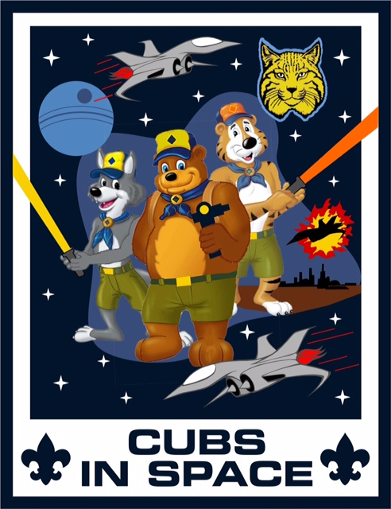
The flag ceremony is led by preassigned Scouters.
They will present the colors and lead the pack in the Pledge of Allegiance.
Preassigned Scouters perform the opening skit Scouts in Space
(Scouters are standing on stage looking up to the sky.)
Cub Scout 1: “What do you think is way out there in space?”
Cub Scout 2: “I think it’s mostly lots of dark space. But there are also billions and billions of stars, galaxies and solar systems, planets, and moons, and blazing comets.”
Cub Scout 3: “Yeah, and maybe in the future lots and lots of people!”
Cub Scout 4: “Think of how cool it will be to be a Cub Scout in space!”
Cub Scout 5: “Maybe we’ll have an adventure hiking on the planets or measuring the galaxy!”
(A sixth Cub Scout walks out dressed in a space helmet with a “Neil Armstrong” name tag.)” Cub Scout 6: “Scouts have already been to space! I am an Eagle Scout. In 1969, I was the first person to walk on the moon, and I placed an American flag there! “That’s one small step for man; one giant leap for mankind.”
All: “Let’s all stand and remember the American flag flying on the moon. Please join us in the Pledge of Allegiance.”
Source: The Philmont Cub Scout Roundtable Supplements March 2018 Cubs of the future - A Scout is Loyal.pdf

